**Instructions: This lab requires a CentOS instllation without a graphical environment. If you have a good running instance of CentOS, feel free to use that VM for this lab assignment. Or, you can practice installation with a clean installation of CentOS using the instructions in Step 1. Once you’ve successfully installed the OS, you’ll use a package manager to install nginx. Nginx is an open-source web server used across the Internet to deliver content globally.**

**I have purposefully limited the number of commands given in this lab. As we progress through the course, I expect you to figure out commands on your own using the tools learned earlier in the course. If you get stuck, use the resources at your fingertips to get you unstuck. And, of course, if you’re really stuck, please e-mail and we’ll work it out together.**

**For this lab, you’ll need to download the CentOS Minimal .iso file and the Ubuntu .iso file from the Lab Files folder under Course Materials (disregard if you already having good copies of the OSs running). Your CentOS will be your web server, and Ubuntu will act like a standard workstation. You will be using the Ubuntu workstation installed from the previous lab.**

**As you work through the lab, I will ask for screenshots of your output. Paste your screenshots into a Word document with a brief explanation of each screenshot. Make sure you have a cover page with your full name.**

1) Download and install CentOS minimal as a VM.

1. Only give your VM 512MB of RAM and make sure you give your VM access to all physical cores on your host computer.
2. Uncheck Audio and leave all other options at their default settings
3. Make sure to select your disk image (.iso) for install.
4. **Important:** Press tab at the CentOS 7 startup screen and enter ‘text’ (without the quotes) at the end of the string, just past quiet. Your output should look something like:
   1. vmlinuz initrd=initrd.img inst.state2=hd:LABEL=CentOS\x207\x20x86_64 rd.live.check quiet text
   2. Adding ‘text’ at the end forces a text-only install. There is no graphical interface using this method.
5. Under Installation, you’ll have 9 different settings, some showing an x, !, or blank. The x means that the setting is ready for installation. The ! means that setting needs your attention before you can install, and a blank box means nothing is configured.
6. Choose a number (1-9) and press Enter to configure that setting. Do this for all settings.

i. For example, press 1 and enter to change language settings. You’ll enter 16 for English, then 1 for English (United States). After you’ve made your changes, you’re sent back to the Installation menu screen. Continue through the remaining settings.

1. Here are some important settings:

i. Under 5) Installation Destination, LVM is selected by default. Change this setting to 1) Standard

Partition ii. 7) Network configuration:

1. Configure device enp0s3 → Check connect automatically after reboot and Apply configuration in installer

* 1. Make sure to create a root password. You do not need to create a user.

1. Once you’re ready, enter b to begin installation
2. Notice, number 4 wants you to verify, simply go into the configuration, verify minimal is selected, and begin the installation.

# ***Screenshot #1, after CentOS has installed, rebooted, and you have a login prompt

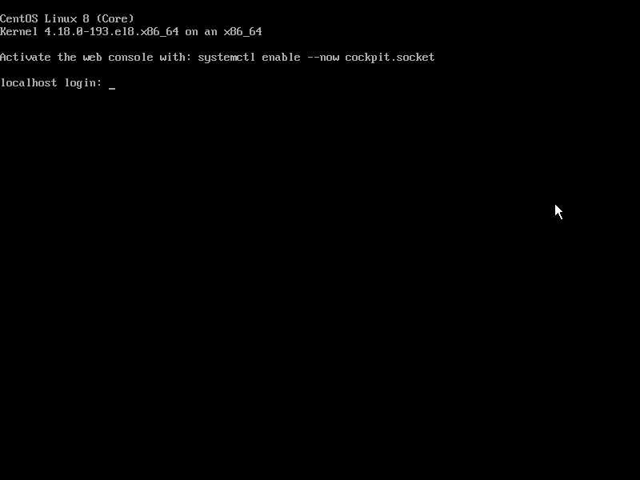

2) Update CentOS

a. After CentOS has installed, login and perform and update using your package manager. Remember, you did not create a user, so the only account you can login with is root using the root password you created during installation.

i. Hint: CentOS uses yum as its package manager. You can use man yum to read the manual for yum. In this lab, you’ll want to update all installed packages.

# ***Screenshot #2, after all updates are complete

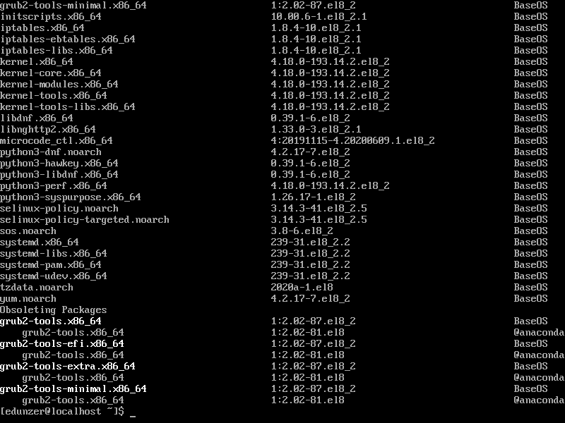

3) Setting up the network

1. Make sure both your Ubuntu and CentOS VM’s are powered off (shutdown).
2. Go into the Settings on your Ubuntu VM
   1. Click the Network tab, and under Adapter 1, change the Attached to: Host-only Adapter. The

Name: should change to VirtualBox Host-Only Ethernet Adapter ii. Click OK to save your settings and Start the Ubuntu VM.

1. Go into the Settings on your CentOS VM
   1. Click the Network tab, click the Adapter 2 tab, check the Enable Network Adapter, and change the Attached to: Host-only Adapter
   2. Click OK to save your settings and Start the CentOS VM.
2. Login to your CentOS VM after it’s done booting. Enter the command, ip addr
   1. In your output you should see enp0s3 with a 10.0.2.x IP address and enp0s8 with a 192.168.56.x address

# ***Screenshot #3, showing the output of your ip addr command

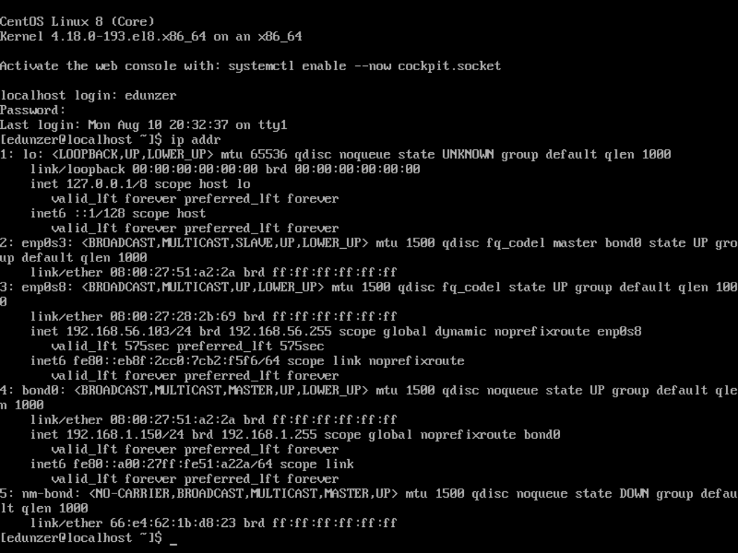

4) Install and start the nginx web server

1. On your CentOS VM, use your package manager to install epel-release and nginx. Again, use the man yum command if you need help on how to install packages.

i. Notice: nginx has dependencies, so you should be install around 48 additional packages listed as dependent packages. Type y, for yes to process.

1. Use the following commands to start and check the status of the nginx service
   1. systemctl start nginx
   2. systemctl status nginx

# ***Screenshot #4, showing an active nginx service PACKAGE UNAVAILABLE FOR BOTH

5) Open your firewall to allow web traffic

a. One of the best features of CentOS is its default security settings. By default, CentOS will not all web traffic to pass through its native firewall. However, now that our CentOS VM is a web server, we need to open ports to allow web traffic. Enter the following firewall commands to open ports 80 and 443 (HTTP and HTTPS).

1. firewall-cmd --permanent --zone=public --add-service=http
2. firewall-cmd --permanent --zone=public --add-service=https
3. firewall-cmd –-reload

# ***Screenshot #5, showing success on all three firewall commands

6) Enable nginx on reboot

1. On your CentOS VM, use the ip addr command to get the IP address of your 2nd network adapter, it should be something like 192.168.56.102.
2. Login to your Ubuntu VM, open the Firefox web browser, and in the address bar, enter the IP address of web server. You should see the Welcome to nginx on Fedora! home page.

**\*\*\*Screenshot #6, showing the default nginx home page.**

1. Reboot your CentOS VM
2. After the CentOS VM has finished rebooting, on your Ubuntu VM, refresh the web page in your Firefox browser. You should receive an error.

# ***Screenshot #7, showing the web page error

1. Log back into your CentOS VM and enter the following command to enable nginx. Above, we used systemctl to start nginx, but that only starts the service. *Enabling* a service guarantees us the service will start after a server reboot. This is critical for any service we want running immediately following a reboot.
   1. systemctl enable nginx
   2. Reboot your CentOS VM
2. After the CentOS has finished reboot, do not login. Refresh web page on your Ubuntu VM. You should receive the nginx default home page.

# ***Screenshot #8, show the nginx home page after enabling nginx

7) Altering our home page

a. In this step, you’ll use SSH (Secure Shell) to remotely manage your CentOS VM.

1. From your Ubuntu VM, open a terminal and use the following command to login to your CentOS VM remotely.

1. ssh root@ 192.168.56.102

a. Remember, your IP address might be slightly different. It could easily be 192.168.56.101, or some other 192.168.x.x. address.

1. Now, use the copy command to make a back of your index.html file, located in /usr/share/nginx/html

# ***Screenshot #9, show your backup copy of index.html in /usr/share/nginx/html (hint: use the list command)

b. Open a new terminal in your Ubuntu VM and use the secure copy command to download a copy of index.html

1. scp user@172.16.1.10:/usr/share/nginx/html/index.html

/home/<username>/Documents/ (there is a space between scp and user, and a space between index.html and /home/…)

1. Use the change directory command to move to your Documents folder and use the list command to see the index.html file you just downloaded from your CentOS VM server.

# ***Screenshot #10, showing your index.html in your Documents folder

1. Now, from Ubuntu, make changes to your index.html file in your Documents directory. The easiest way is to use gedit, a graphical text editor.
   1. gedit index.html
   2. In gedit, scroll down and find <h1>Welcome to <strong>nginx</strong> on Fedora!
   3. Change nginx to your first and last name. Save the file and close gedit.
2. Finally, use secure copy to upload your altered index.html file to your web server

* 1. scp index.html root@172.16.1.10:/usr/share/nginx/html/index.html

1. From Firefox, refresh your web page and notice your name is now displayed on the default nginx home page.

# ***Screenshot #11, the changed nginx home page